WEEK 3 TASK: BUSINESS PROCESS MAPPING AND OPTIMIZATION

1. Introduction
Business process mapping is an important Business Analysis technique used to understand how a business activity is performed from start to finish. It helps Business Analysts visualize individual process steps, identify responsibilities, find bottlenecks, and identify opportunities for improvement.
This project focuses on the E-commerce Order Fulfillment Process, which is a common business process involving several activities such as receiving an order, confirming payment, checking inventory, preparing the order, arranging shipment, and delivering the order to the customer.
The purpose of this task is to create a detailed process map of the current order fulfillment workflow and analyze its efficiency. The analysis will identify bottlenecks, redundant activities, potential error points, communication gaps, and other risks that may affect business performance and customer satisfaction.
Based on the identified issues, practical optimization recommendations will be proposed. The recommendations will focus on reducing unnecessary manual activities, improving information flow, reducing processing delays, improving order visibility, and minimizing operational risks.
A future-state process map will also be developed to show how the process could operate after the recommended improvements are implemented. The overall objective is to demonstrate how business process mapping can support better efficiency, productivity, customer experience, and decision-making.

2. Process Selection and Background

2.1 Selected Business Process
The selected process for this project is the E-commerce Order Fulfillment Process.
Order fulfillment is the process through which a customer order is received, processed, prepared, shipped, and delivered to the customer. It involves different business functions, including sales, inventory management, warehouse operations, finance, logistics, and customer service.

2.2 Process Background
In a typical e-commerce business, the process begins when a customer places an order through the company's online platform. The order is recorded and the payment is processed. The business then checks whether the required products are available in inventory.
If the products are available, the order is sent for picking and packing. After the order is prepared, it is handed over to a courier or delivery service. The order is then transported to the customer, and the delivery status is updated.
If an issue occurs, such as payment failure, insufficient inventory, incorrect customer information, or a delivery delay, the order may require additional processing or intervention.

2.3 Reason for Selecting the Process
The E-commerce Order Fulfillment Process was selected because it is a common business process with multiple connected activities and stakeholders. A delay or error at one stage can affect the following stages and ultimately impact customer satisfaction.
Mapping this process provides an opportunity to identify:
- Unnecessary or repeated activities.
- Delays between process steps.
- Manual activities that could be automated.
- Communication gaps between departments.
- Potential order-processing errors.
- Inventory and delivery-related risks.
- Opportunities to improve customer visibility.

2.4 Main Stakeholders
The main stakeholders involved in the process include:
Stakeholder | Role
Customer | Places and receives the order
Sales/Order Management Team | Receives and processes orders
Finance/Payment Team | Handles payment confirmation
Inventory Team | Checks product availability
Warehouse Team | Picks and packs products
Logistics/Courier Team | Ships and delivers orders
Customer Service Team | Handles customer questions and issues
Management | Monitors process performance

2.5 Process Objective
The main objective of the order fulfillment process is to deliver the correct product to the correct customer within the expected time while maintaining accurate order, payment, inventory, and delivery information.
The process analysis will examine whether the current workflow achieves this objective efficiently and where improvements can be introduced.

3. Process Scope

3.1 Scope Definition
The scope of this analysis covers the E-commerce Order Fulfillment Process, starting from the point when a customer places an order and ending when the order is successfully delivered to the customer.
The analysis focuses on the activities, decisions, handoffs, and information flows involved in processing and delivering an order. It also considers potential delays, errors, bottlenecks, and risks that may affect the efficiency of the process.

3.2 Process Start Point
The process begins when:
Customers place an order through the e-commerce platform.
The order information is then recorded and made available for further processing.

3.3 Process End Point
The process ends when:
The order is successfully delivered to the customer, and the delivery status is updated.

3.4 Activities Included in Scope
The following activities are included:
- Customers place an order.
- Order details are recorded.
- Payment is processed.
- Payment status is confirmed.
- Product availability is checked.
- The order is sent to the warehouse.
- The product is picked up.
- The product is packed.
- Shipment is prepared.
- Courier collects the order.
- The order is delivered to the customer.
- Delivery status is updated.

3.5 Activities Outside the Scope
The following activities are outside the main scope of this analysis:
- Product design and manufacturing.
- Supplier procurement.
- Marketing and advertising activities.
- Customer account registration.
- Long-term customer relationship management.
- Product returns after the delivery process.
These activities may interact with the order fulfillment process but are not the primary focus of this process-mapping exercise.

3.6 Scope Summary
Scope Element | Description
Process | E-commerce Order Fulfillment
Start | Customer places an order
End | Order is delivered and status is updated
Focus | Order processing and delivery
Key Areas | Payment, inventory, warehouse, shipping and delivery
Main Stakeholders | Customer, Operations, Finance, Warehouse, Logistics and Customer Service
Outside Scope | Procurement, marketing, manufacturing and long-term customer management

3.7 Scope Objective
The objective of defining the scope is to provide a clear boundary for the process analysis. This ensures that the process map focuses on the activities directly related to order fulfillment and allows inefficiencies, bottlenecks, risks, and optimization opportunities to be identified accurately.

4. Current-State Process Map
The current state process map represents the existing E-commerce Order Fulfillment Process from the time a customer places an order until the order is delivered. The map includes the main activities, decision points, and exception paths involved in the process.
The purpose of the current state map is to understand how the process operates before improvements are introduced. It also provides a basis for identifying bottlenecks, redundant activities, communication gaps, and potential risks.

4.1 Current-State Process Flow
The current process follows these major steps:
- Customers place an order through the e-commerce platform.
- The order details are recorded in the system.
- Payment is processed.
- The payment status is checked.
- If payment fails, the customer is notified and the process ends or requires payment correction.
- If payment is successful, product availability is checked.
- If the product is unavailable, the customer is notified and the order may be cancelled or placed on backorder.
- If the product is available, the order is sent to the warehouse.
- Warehouse staff pick the required product.
- The product is packed.
- The shipment is prepared.
- The courier collects orders.
- The order is delivered to the customer.
- The delivery status is checked.
- If delivery is unsuccessful, a delivery exception may require customer service follow-up or another delivery attempt.
- If delivery is successful, the delivery status is updated and the process is completed.

4.2 Current-State Process Map Structure
The flowchart should contain the following sequence: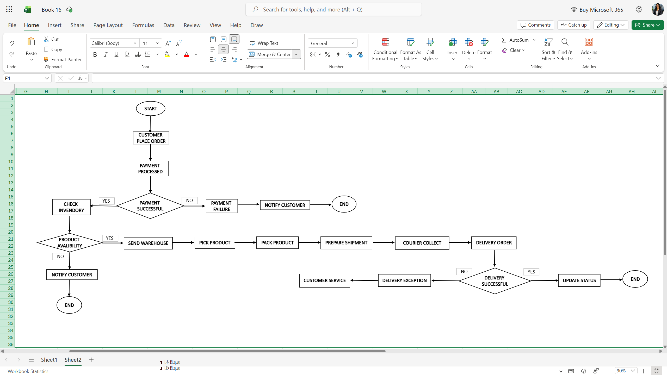
Figure 1: Current-State E-commerce Order Fulfillment Process Map

4.3 Process Map Notation
The following standard flowchart shapes should be used when creating the process map in Excel, Visio, or another suitable tool:
Shape | Use
Oval | Start and End
Rectangle | Process/activity
Diamond | Decision point
Arrow | Direction of process flow

4.4 Key Decision Points
Three important decision points are included in the current-state process:
Decision 1 — Payment Successful?
Determines whether the order can continue for fulfillment.
Decision 2 — Product Available?
Determines whether the order can be sent to the warehouse for preparation.
Decision 3 — Delivered Successfully?
Determines whether the order is completed or requires exception handling.
These decision points are important because they represent areas where delays, errors, or additional work may occur.

4.5 Current-State Process Map Evidence
After creating the flowchart, insert a screenshot of the completed process map into the report.
Figure 1: Current-State E-commerce Order Fulfillment Process Map
The screenshot should clearly show the complete process, including activities, decision points, arrows, and exception paths.

4.6 Purpose of the Current-State Map
The current state process map provides a visual representation of the existing workflow. It will be used in the following sections to identify process bottlenecks, redundant activities, potential error points, and operational risks. The findings will then be used to develop practical optimization recommendations and a future-state process map.

5. Detailed Process Description
The current state E-commerce Order Fulfillment Process consists of several activities and decision points. Each activity contributes to moving the order from placement to final delivery.
No. | Process Step | Description | Responsible Area
1 | Customer Places Order | The customer selects products and submits an order through the e-commerce platform. | Customer
2 | Record Order Details | The order information, including products, quantity, customer details, and delivery address, is recorded. | Order Management
3 | Process Payment | The customer's selected payment method is processed. | Finance/Payment System
4 | Check Payment Status | The payment result is checked to determine whether the order can continue. | Finance/Order Management
5 | Check Inventory | Product availability is checked before the order is sent for fulfillment. | Inventory Team
6 | Send Order to Warehouse | The confirmed order is forwarded to the warehouse for preparation. | Order Management/Warehouse
7 | Pick Product | Warehouse staff locate and collect the required products. | Warehouse Team
8 | Pack Product | The selected products are checked and securely packed for shipment. | Warehouse Team
9 | Prepare Shipment | Shipping information and delivery arrangements are prepared. | Warehouse/Logistics
10 | Courier Collects Order | The courier collects the prepared package from the business. | Logistics/Courier
11 | Deliver Order | The package is transported and delivered to the customer. | Courier
12 | Check Delivery Status | The delivery outcome is checked to determine whether the order was successfully delivered. | Logistics/Customer Service
13 | Handle Delivery Exception | If delivery fails, the issue is investigated and another delivery attempt or customer-service action may be required. | Logistics/Customer Service
14 | Update Delivery Status | After successful delivery, the order status is updated to show completion. | Order Management/System
15 | End | The fulfillment process is complete. | —

5.1 Decision Points
The process contains three important decision points:
Payment Successful?
If payment is unsuccessful, the order cannot normally proceed until the payment issue is resolved.
Product Available?
If the required product is unavailable, the order may need to be cancelled, delayed, or placed on backorder.
Delivered Successfully?
If delivery is unsuccessful, additional investigation, communication, or another delivery attempt may be required.

5.2 Process Handoffs
Several handoffs occur between different teams during the process. Examples include:
- Order Management → Finance/Payment
- Order Management → Inventory
- Order Management → Warehouse
- Warehouse → Logistics
- Logistics → Customer Service when delivery problems occur
These handoffs are important areas for further analysis because delays or communication gaps between teams can affect the overall process of time.

5.3 Summary
The detailed process description provides a clear explanation of each activity represented in the current state process map. The next stage of the analysis will examine these activities to identify bottlenecks, redundant steps, delays, and potential areas for improvement.

6. Process Analysis
The current-state process was reviewed to identify activities that may cause delays, increase manual effort, create communication problems, or increase the possibility of errors. The analysis focuses on the movement of information and orders between different teams.

6.1 Process Analysis Findings
Process Area | Identified Issue | Impact
Order Recording | Order information may require manual checking or correction. | Can increase processing time and create data-entry errors.
Payment Confirmation | Payment confirmation may delay further order processing. | Orders may remain pending and affect fulfillment time.
Inventory Check | Inventory information may not always be immediately available or accurate. | Can result in delayed or cancelled orders.
Order Handoff | Orders are transferred between Order Management and Warehouse. | Communication gaps can cause delays or incorrect processing.
Picking | Warehouse staff manually locate products. | Picking errors can result in incorrect orders.
Packing | Products require manual checking and packing. | Incorrect or damaged items may be shipped.
Shipment Preparation | Shipping information must be prepared correctly. | Incorrect information can cause delivery problems.
Delivery | Delivery depends on external courier operations. | Delays or failed deliveries can affect customer satisfaction.
Exception Handling | Failed deliveries require additional investigation and communication. | Creates additional work and increases resolution time.
Status Updates | Order and delivery statuses may require updates across systems. | Delayed updates can lead to customer enquiries.

6.2 Bottlenecks
The main potential bottlenecks identified are:
1. Payment Confirmation
Orders may wait for payment confirmation before fulfillment can continue.
2. Inventory Verification
A delay in confirming product availability can prevent the order from moving to the warehouse.
3. Warehouse Processing
Picking and packing are partly dependent on manual activities, which can become slower when order volumes increase.
4. Delivery Exceptions
Failed or delayed deliveries require additional investigation and communication between Logistics and Customer Service.
5. Information Handoffs
Moving information between different teams can create delays if information is incomplete or not updated quickly.

6.3 Redundant or Repeated Activities
Some activities may create unnecessary additional work:
- Repeated checking of order information.
- Manually check order status across different systems.
- Re-entering information during team handoffs.
- Customer Service contacts other departments to obtain order updates.
- Repeated communication when delivery exceptions occur.
These activities should be reviewed to determine whether automation or better system integration can reduce the workload.

6.4 Potential Error Points
The following areas have a higher possibility of errors:
- Incorrect customer or delivery information.
- Incorrect payment status.
- Incorrect inventory information.
- Picking the wrong product.
- Packing the wrong quantity.
- Incorrect shipping information.
- Delayed or incorrect order status updates.
Errors at these points can result in additional processing, customer complaints, returns, delivery delays, and increased operational costs.

6.5 Process Analysis Summary
The current state analysis shows that the major improvement opportunities are related to manual activities, information handoffs, system visibility, warehouse processing, and exception handling.
The process could be improved by reducing unnecessary manual work, improving system integration, providing better order visibility, introducing automated notifications, and creating clearer exception-handling procedures. These improvements will be examined in the following sections.

6.6 Current-State Process Map Showing Bottlenecks
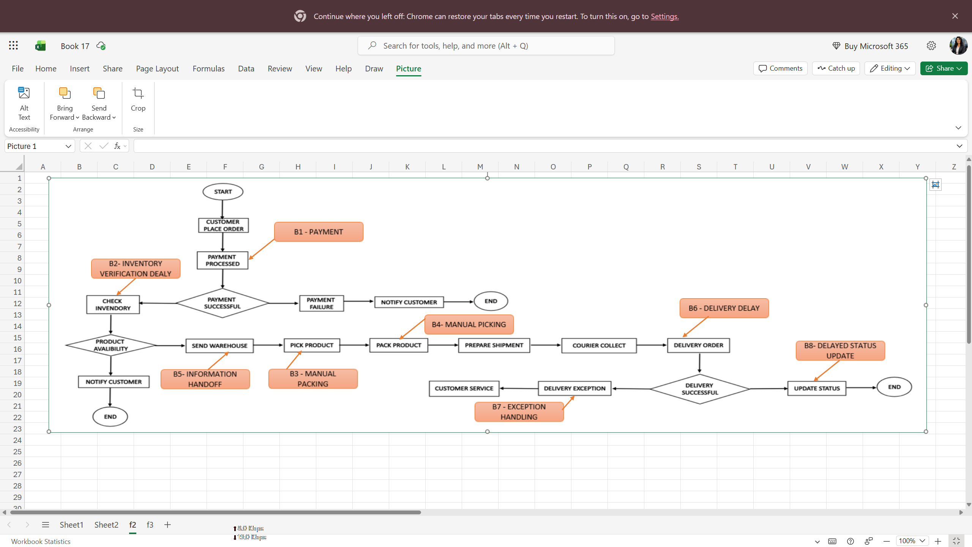Figure 2: Current-State Process Map Showing Bottlenecks and Inefficiencies

7. Bottlenecks and Inefficiencies
The current-state process analysis identified several bottlenecks and inefficiencies that may reduce the speed and reliability of the E-commerce Order Fulfillment Process. These issues can increase processing time, create additional manual work, and negatively affect customer satisfaction.

7.1 Identified Bottlenecks
No. | Bottleneck | Possible Cause | Business Impact
1 | Payment confirmation delay | Payment status may require additional processing or verification. | Orders may remain pending, and fulfillment may be delayed.
2 | Inventory verification | Inventory information may not be updated immediately. | Orders may be delayed or cancelled if products are unavailable.
3 | Manual warehouse activities | Picking and packing depend on manual activities. | Higher processing time and increased risk of errors.
4 | Information handoffs | Different teams may depend on information from each other. | Communication gaps can delay order processing.
5 | Delivery delays | Delivery depends on courier operations and external conditions. | Customers may receive orders later than expected.
6 | Delivery exception handling | Failed deliveries require additional investigation and communication. | Increases workload and resolution time.
7 | Delayed status updates | Order information may not be updated immediately across systems. | Customers may contact Customer Service for updates.

7.2 Redundant Activities
The analysis also identified activities that may create unnecessary work:
- Repeatedly checking order information.
- Manually transfer information between teams.
- Rechecking payment or inventory information.
- Customer Service contacts other departments for order updates.
- Repeated communication during delivery exceptions.
These activities may not add direct value to the customer and could potentially be reduced through better system integration and automation.

7.3 Major Inefficiency — Manual Processing
Manual activities are one of the main sources of inefficiency in the current process. Employees may need to manually check information, communicate with other departments, or update order statuses.
For example, if Customer Service cannot directly access the latest delivery information, staff may need to contact the Logistics Team before responding to the customer. This creates additional work and increases response time.

7.4 Major Inefficiency — Information Gaps
Another important inefficiency is the movement of information between departments. Order Management, Finance, Inventory, Warehouse, Logistics, and Customer Service all require accurate information.
If information is not available at the right time, one department may have to wait for another department to provide an update. This can create delays and reduce process efficiency.

7.5 Business Impact
The identified bottlenecks and inefficiencies may result in:
- Longer order-processing times.
- Increased employee workload.
- Higher possibility of data entry errors.
- Delayed customer responses.
- Increased customer enquiries.
- Delivery delays.
- Higher operational costs.
- Reduced customer satisfaction.

7.6 Improvement Opportunities
The main opportunities for improvement include:
- Automating payment and order status updates.
- Improving inventory visibility.
- Reducing manual data entry.
- Integrating order, inventory, payment, and delivery of information.
- Providing Customer Service with direct access to order information.
- Introducing automated customer notifications.
- Establishing a standard process for handling delivery exceptions.

7.7 Summary
The analysis shows that the major bottlenecks are related to manual processing, information handoffs, inventory verification, delivery exceptions, and delayed status updates. Addressing these areas can reduce processing time, improve information accuracy, reduce employee workload, and improve customer experience.
These findings will be used to identify the key risks in the current process and develop practical optimization recommendations.

8. Process Risks and Error Points
The current state process contains several points where errors, delays, or failures may occur. Identifying these risks is important because they can affect order accuracy, delivery performance, operational costs, and customer satisfaction.

8.1 Risk Analysis
No. | Risk / Error Point | Possible Cause | Potential Impact | Suggested Control
1 | Incorrect order information | Manual data entry or incorrect customer details | Wrong product or delivery information | Use automated order validation
2 | Payment failure | Payment processing issue | Order processing is delayed | Provide automatic payment-status updates
3 | Incorrect inventory information | Inventory not updated on time | Order cancellation or delay | Improve real-time inventory visibility
4 | Wrong product picked | Manual picking error | Incorrect order delivered | Use barcode/product scanning
5 | Incorrect packing | Manual checking or packing error | Damaged or incomplete order | Introduce packing verification
6 | Incorrect shipping information | Data-entry or communication error | Delivery delay or failed delivery | Validate shipping details before dispatch
7 | Delayed order-status update | Manual or disconnected systems | Increased customer enquiries | Automate status updates
8 | Delivery failure | Incorrect address, customer unavailable, or courier issue | Additional delivery cost and delay | Introduce exception alerts and follow-up procedures
9 | Communication gap | Information not shared between teams | Slow issue resolution | Use a shared order-status system
10 | Unauthorized access | Weak access controls | Exposure of sensitive information | Use role-based access controls

8.2 High-Risk Areas
The analysis identifies three areas that require particular attention:
Inventory Accuracy
Incorrect inventory information can result in an order being accepted even when the product is unavailable. This may lead to cancellation, customer dissatisfaction, and additional processing.
Order Picking and Packing
Manual warehouse activities create opportunities for incorrect products or quantities to be selected and shipped.
Delivery and Status Updates
Delivery problems and delayed status updates can result in additional customer enquiries and increased workload for Customer Service.

8.3 Risk Reduction Approach
The identified risks can be reduced through a combination of process and technology improvements. These include:
- Automating order validation.
- Improving inventory visibility.
- Using barcode or scanning controls in the warehouse.
- Validating shipping information before dispatching.
- Automating order and delivery notifications.
- Providing better information sharing between departments.
- Using role-based access controls.
- Creating a standard process for handling delivery exceptions.

8.4 Summary
The risk analysis shows that errors can occur at different stages of the order fulfillment process, particularly during data entry, inventory checking, warehouse activities, shipping, delivery, and status updates. These risks can result in delays, additional costs, incorrect orders, and customer dissatisfaction.
Identifying these risks provides a basis for developing practical optimization recommendations. The next section will focus on the specific improvements that can make the process faster, more reliable, and more efficient.

8.5 Visual Representation of Risk and Error Points
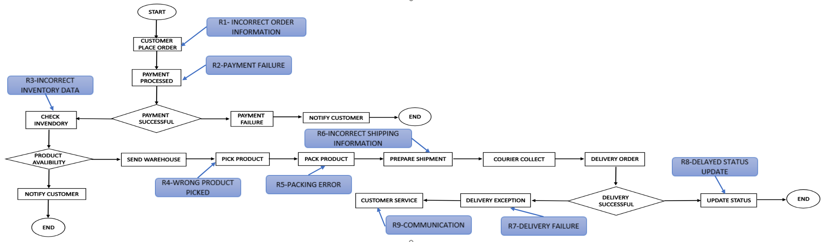
Figure 3: Current-State Process Map Showing Key Risk and Error Points

9. Optimization Recommendations
Based on the analysis of the current-state E-commerce Order Fulfillment Process, several opportunities for improvement were identified. The recommendations focus on reducing manual work, improving information flow, reducing errors, and improving customer service.

9.1 Recommended Process Improvements
No. | Current Problem | Recommended Optimization | Expected Benefit
1 | Manual order and status checking | Automate order-status updates | Reduces manual work and processing delays
2 | Delayed inventory verification | Introduce better real-time inventory visibility | Reduces order cancellations and delays
3 | Manual warehouse picking | Use barcode or product scanning | Reduces picking errors
4 | Manual packing verification | Introduce a packing checklist or scanning validation | Reduces incorrect or incomplete orders
5 | Information gaps between departments | Integrate order, inventory, payment, and delivery information | Improves information flow
6 | Customer enquiries about order status | Provide customer self-service order tracking | Reduces unnecessary customer enquiries
7 | Delivery exceptions handled manually | Create automated exception alerts | Enables faster issue resolution
8 | Delayed customer communication | Automate important order notifications | Improves customer experience
9 | Incorrect shipping information | Validate delivery details before dispatch | Reduces failed deliveries
10 | Sensitive information access | Introduce role-based access controls | Reduces security risks

9.2 Recommendation 1 — Automate Order Status Updates
Order status updates should be automated whenever an important event occurs, such as order confirmation, payment completion, shipment, or delivery.
Justification:
Automation reduces the need for employees to manually update order information and provides customers with more timely information.

9.3 Recommendation 2 — Improve Inventory Visibility
Inventory information should be updated consistently and made available to the relevant teams.
Justification:
Better inventory visibility can reduce situations where customers place orders for products that are unavailable. It can also help Operations and Warehouse teams plan fulfillment more effectively.

9.4 Recommendation 3 — Introduce Barcode Scanning
Barcode scanning can be used during picking and packing to verify products and quantities.
Justification:
Scanning provides an additional validation step and can reduce errors caused by manual product selection.

9.5 Recommendation 4 — Integrate Business Information
Order, payment, inventory, warehouse, and delivery information should be connected where technically feasible.
Justification:
Better integration reduces repeated data entry and allows authorized employees to access accurate information without repeatedly contacting other departments.

9.6 Recommendation 5 — Provide Customer Order Tracking
Customers should be provided with a simple way to view the status of their order.
Justification:
Self-service tracking can reduce unnecessary customer enquiries and improve customer confidence in the fulfillment process.

9.7 Recommendation 6 — Automate Exception Alerts
The system should generate alerts when important problems occur, such as payment failure, inventory issues, shipment delays, or failed delivery.
Justification:
Early notification allows the responsible team to investigate problems before they become larger customer or operational issues.

9.8 Recommendation 7 — Improve Shipping Validation
Customer address and shipping information should be checked before an order is dispatched.
Justification:
Early validation can reduce failed deliveries, additional courier costs, and delivery delays.

9.9 Recommendation 8 — Strengthen Access Controls
Access to payment, customer, and other sensitive information should be restricted according to user roles.
Justification:
Role-based access helps ensure that employees can access only the information required for their responsibilities.

9.10 Feasibility of Recommendations
The recommendations are designed to be practical and can be implemented in stages. High-value improvements such as automated status updates, better inventory visibility, and improved information integration should be considered first. More advanced improvements can be introduced after evaluating cost, technical feasibility, resources, and business impact.

9.11 Expected Overall Improvement
The recommended changes are expected to:
- Reduce manual processing.
- Reduce order-processing delays.
- Improve order accuracy.
- Improve inventory visibility.
- Reduce delivery-related errors.
- Reduce customer enquiries.
- Improve communication between departments.
- Improve customer satisfaction.
- Reduce operational risks.
- Support better business decision making.

9.12 Summary
The proposed optimizations directly address the bottlenecks and risks identified in the current state process. The recommendations combine process improvements, automation, better information sharing, and operational controls. Implementing these changes can make the order fulfillment process more efficient, reliable, and customer focused.

9.13 Visual Representation of Proposed Process Improvements
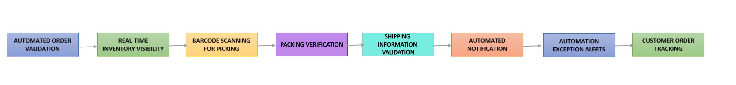
Figure 4: Proposed E-commerce Order Fulfillment Process Improvements

10.Future-State Process Map
The future-state process map represents the improved E-commerce Order Fulfillment Process after applying the optimization recommendations identified in the previous sections.
The objective of the future-state process is to reduce manual activities, improve information flow, reduce errors, provide faster order visibility, and improve customer experience.

10.1 Future-State Process Flow
The improved process follows these steps:
- Customers place an order through the e-commerce platform.
- The system automatically validates the order information.
- Payment is processed.
- The system automatically confirms the payment status.
- The system checks inventory availability.
- If the product is unavailable, the customer receives an automatic notification.
- If the product is available, the order is automatically released to the warehouse.
- Warehouse staff scan the product while picking it up.
- The product is packed and verified using scanning or a checklist.
- Shipping information is validated before dispatching.
- The courier collects orders.
- Delivery tracking information is updated.
- Customers receive automated delivery status notifications.
- If a delivery exception occurs, an alert is automatically sent to the responsible team.
- Customer Service or Logistics handles the exception.
- After successful delivery, the system automatically updates the order status.
- The process is complete.

10.2 Future-State Process Map Structure
Use the following sequence when creating the improved flowchart:
Figure 5: Future-State E-commerce Order Fulfillment Process Map

10.3 Key Improvements in the Future-State Process
Current-State Issue | Future-State Improvement
Manual order checking | Automated order validation
Delayed payment confirmation | Automated payment-status confirmation
Inventory information gaps | Improved inventory visibility
Manual picking | Barcode/product scanning
Packing errors | Packing verification
Incorrect shipping information | Shipping validation before dispatch
Delayed customer updates | Automated notifications
Manual exception identification | Automated exception alerts
Repeated information checking | Integrated information
Limited customer visibility | Customer order tracking

10.4 Expected Process Improvement
The future-state process is expected to reduce unnecessary manual activities and improve the flow of information between Order Management, Finance, Inventory, Warehouse, Logistics, and Customer Service.
Automation will allow routine activities such as status updates and notifications to occur with less manual intervention. Scanning and validation controls will help reduce order and warehouse errors. Improved exception alerts will allow responsible teams to respond to problems more quickly.

10.5 Future-State Process Map Evidence
The completed future-state flowchart should be inserted into the report.
Figure 5: Future-State E-commerce Order Fulfillment Process Map
The process map should clearly show the improved activities, decision points, automated steps, exception handling, and final delivery.

10.6 Comparison of Current and Future State
Area | Current State | Future State
Order Validation | May involve manual checking | Automated validation
Payment Status | May require checking | Automated confirmation
Inventory | Information may be delayed | Improved visibility
Picking | Manual | Scanning supported
Packing | Manual checking | Verification control
Customer Updates | May be delayed | Automated notifications
Exceptions | Manual identification | Automated alerts
Information Flow | Multiple handoffs | Better integration
Customer Tracking | Limited visibility | Improved self-service tracking

10.7 Summary
The future-state process introduces automation, validation, scanning, improved information sharing, and proactive exception handling. These changes address the major bottlenecks and risks identified in the current state analysis.
The future-state map provides a practical representation of how the e-commerce order fulfillment process can become faster, more accurate, and more customer-focused.

11. Implementation Considerations
The proposed improvements should be implemented in a planned and controlled manner. The organization should first identify the most important problems and then introduce improvements gradually. This approach can reduce operational disruption and allow the organization to measure the results.

11.1 Implementation Plan
Improvement | Implementation Action | Responsible Team | Expected Result
Automated order validation | Configure system validation rules | IT / Order Management | Fewer order-entry errors
Payment automation | Integrate payment-status updates | IT / Finance | Faster payment confirmation
Inventory visibility | Connect order and inventory information | IT / Inventory | Fewer stock-related delays
Barcode scanning | Introduce scanning during picking | Warehouse / IT | Fewer picking errors
Packing verification | Use checklist or scanning controls | Warehouse | Fewer packing errors
Shipping validation | Validate address and shipping details | Order Management / Logistics | Fewer delivery failures
Automated notifications | Configure customer notifications | IT / Customer Service | Better customer communication
Exception alerts | Create automatic delivery alerts | Logistics / Customer Service | Faster problem resolution
Order tracking | Provide customer self-service tracking | IT / Customer Service | Fewer status enquiries

11.2 Implementation Priorities
The organization should prioritize improvements based on business impact, cost, and implementation difficulty.
High Priority:
- Automated order and payment-status updates
- Improved inventory visibility
- Barcode scanning for warehouse picking
- Shipping information validation
Medium Priority:
- Automated customer notifications
- Packing verification
- Delivery exception alerts
Lower Priority:
- Additional reporting and performance dashboards
- Further process automation after the main improvements is stable

11.3 Change Management
Employees should be informed about the proposed process changes before implementation. Training should be provided to warehouse, customer service, order management, finance, and logistics employees.
The organization should also test the improved process before full implementation. A pilot implementation can help identify technical problems, employee concerns, and unexpected process issues.

11.4 Monitoring and Measurement
After implementation, the organization should monitor key performance indicators (KPIs) to determine whether the improvements are successful.
Suggested KPIs include:
- Average order processing time
- Payment confirmation time
- Order picking error rate
- Packing error rate
- Inventory-related cancellations
- Delivery delay rate
- Delivery exception resolution time
- Number of customer status enquiries
- Customer satisfaction

11.5 Expected Benefits
Successful implementation of the future-state process can provide several benefits:
- Reduced order processing time.
- Fewer manual errors.
- Better inventory accuracy.
- Faster warehouse processing.
- Fewer incorrect orders.
- Faster resolution of delivery problems.
- Reduced customer enquiries.
- Better visibility of order status.
- Improved employee productivity.
- Improved customer satisfaction.

11.6 Conclusion
The implementation approach should focus on practical improvements that provide measurable business value. Automation, system integration, scanning, validation, and better communication can address the major problems identified in the current state process.
A phased implementation with employee training, testing, and KPI monitoring will help ensure that the improvements are feasible and sustainable.

12. Before-and-After Process Comparison
The comparison between the current-state and future-state processes helps demonstrate how the proposed improvements address identified bottlenecks, risks, and inefficiencies.

12.1 Current-State vs Future-State
Process Area | Current-State Process | Future-State Process | Expected Improvement
Order Entry | Manual checking may be required | Automated validation | Fewer data-entry errors
Payment | Payment confirmation may be delayed | Automatic payment confirmation | Faster order processing
Inventory | Inventory information may not be immediately available | Improved inventory visibility | Fewer cancellations and delays
Warehouse Picking | Manual picking | Barcode/product scanning | Fewer picking errors
Packing | Manual verification | Scanning/checklist verification | Fewer packing errors
Shipping | Information may require manual checking | Shipping information validation | Fewer delivery problems
Customer Updates | Updates may be delayed | Automated notifications | Better customer communication
Delivery Tracking | Status may require manual updates | Automated tracking updates | Improved visibility
Exception Handling | Problems may be identified manually | Automatic exception alerts | Faster resolution
Information Sharing | Multiple handoffs between teams | Better system integration | Reduced communication gaps
Customer Service | Receives repeated status enquiries | Customers can track orders | Reduced enquiry volume

12.2 Business Impact
The future-state process provides improvements across time, quality, cost, and customer experience.
Time: Automation reduces delays in payment confirmation, order processing, and status updates.
Quality: Validation and scanning reduce incorrect orders, picking errors, and packing problems.
Productivity: Employees spend less time on repetitive checking and manual status updates.
Customer Experience: Automated notifications and tracking provide customers with better visibility of their orders.
Risk Reduction: Validation, scanning, and automated alerts reduce operational and communication risks.

12.3 Overall Improvement
The proposed future-state process changes the fulfillment workflow from a process that depends heavily on manual checking and communication to a more automated and integrated process.
The improvements do not require every activity to be fully automated. Instead, automation should be applied to repetitive activities, while employees continue to manage decisions, exceptions, and activities that require human judgment.
This approach provides a practical balance between technology and employee involvement.

12.4 Summary
The before-and-after comparison demonstrates that the proposed optimization strategies directly address the problems identified in the current state process. The future-state process is expected to improve efficiency, reduce errors, improve communication, reduce customer enquiries, and provide a better overall customer experience.

13. Conclusion
This report analyzed the E-commerce Order Fulfillment Process using business process mapping and optimization techniques. The current-state process was mapped from the point at which a customer places an order until the order is delivered, and the delivery status is updated.
The analysis identified several important bottlenecks and inefficiencies, including payment confirmation delays, inventory verification issues, manual warehouse activities, communication gaps, delivery delays, and manual exception handling. Potential risks such as incorrect order information, picking and packing errors, incorrect shipping information, delivery failures, and delayed status updates were also identified.
To address these issues, several practical improvements were recommended. These include automated order validation, improved inventory visibility, barcode scanning, packing verification, shipping information validation, automated customer notifications, integrated information systems, and automated delivery exception alerts.
A future-state process was developed to demonstrate how these improvements can create a more efficient and reliable fulfillment process. The proposed process reduces unnecessary manual activities while allowing employees to focus on exceptions and activities that require human judgment.
Overall, the proposed improvements can help reduce processing time, minimize errors, improve communication, increase employee productivity, reduce customer enquiries, and improve customer satisfaction. The analysis demonstrates how business process mapping can help a Business Analyst understand an existing process, identify improvement opportunities, and recommend practical solutions that provide measurable business value.

